JENKINS

WHAT IS JENKINS

Jenkins is an open source server capable of orchestrating a chain of actions that help to achieve the process in an automated fashion

Jenkins supports the complete development lifecycle of software from building, testing, documenting the software, deploying and other stages of a software development lifecycle.

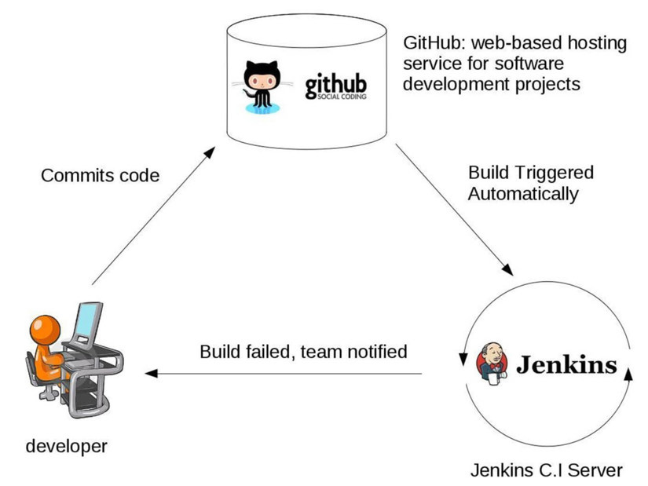

JENKINS MASTER-SLAVE CONFIGURATION

This single Jenkins server was not enough to meet certain requirements like:

* Sometimes you might need several different environments to test your builds. This cannot be done by a single Jenkins server.
* If larger and heavier projects get built on a regular basis then a single Jenkins server cannot simply handle the entire load.

To address the above-stated needs, Jenkins distributed architecture came into the picture.

